1. Multi-Class Classification

Definition
A multi-class classification problem is one where the target variable has more than two classes.
Output classes ≥ 3

Given Confusion Matrix (Multi-Class)
Actual \ Predicted | Setosa | Versicolor | Virginica
Setosa | 18 | 1 | 1
Versicolor | 2 | 15 | 3
Virginica | 1 | 2 | 17

Step 1: Accuracy (Overall)

Formula

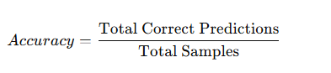

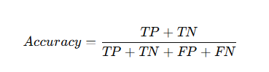

- Correct predictions (Diagonal) = 18 + 15 + 17 = 50
- Total samples = 60
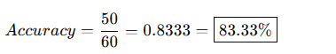
Step 2: Precision, Recall, F1-Score (Class-wise)

Class 1: Setosa
- TP = 18
- FP = 2 + 1 = 3
- FN = 1 + 1 = 2

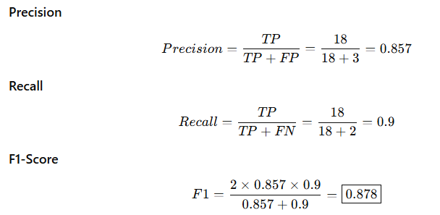

Class 2: Versicolor
- TP = 15
- FP = 1 + 2 = 3
- FN = 2 + 3 = 5

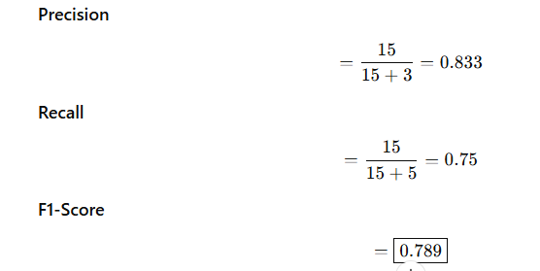

🔹 Class 3: Virginica
- TP = 17
- FP = 1 + 3 = 4
- FN = 1 + 2 = 3

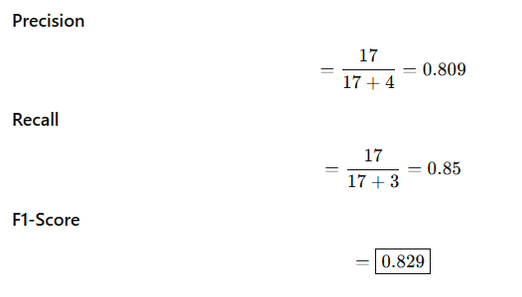

Final Summary Table
Class | Precision | Recall | F1-Score
Setosa | 0.857 | 0.90 | 0.878
Versicolor | 0.833 | 0.75 | 0.789
Virginica | 0.809 | 0.85 | 0.829

2. A spam classifier produces the following confusion matrix:

Actual \ Predicted | Spam | Not Spam
Spam | 90 | 10
Not Spam | 20 | 80

Find:
  - Accuracy
  - Precision
  - Recall

Solution

TP = 90, FN = 10, FP = 20, TN = 80

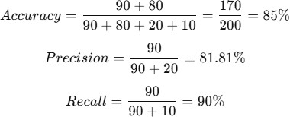

3. In a classification task, the following outcomes are observed:

For ID 1, y_i is 1 and y_predicted is 1.
For ID 2, y_i is 1 and y_predicted is 0.
For ID 3, y_i is 0 and y_predicted is 1.
For ID 4, y_i is 1 and y_predicted is 0.
For ID 5, y_i is 0 and y_predicted is 0.
For ID 6, y_i is 1 and y_predicted is 1.

What is the value of precision in this case?

Solution :

ID | Actual (y) | Predicted
1 | 1 | 1 → TP
2 | 1 | 0
3 | 0 | 1 → FP
4 | 1 | 0
5 | 0 | 0
6 | 1 | 1 → TP

- True Positives (TP) = 2 (ID 1, 6)
- False Positives (FP) = 1 (ID 3)

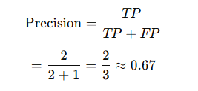

4. Suppose I have 10,000 emails in my mailbox out of which 200 are spams.
The spam detection system detects 150 mails as spams, out of which 50 are actually spams.
What is the precision and recall of my spam detection system?

Solution:
- Total actual spam emails = 200
- Emails predicted as spam = 150
- Correctly predicted spam (True Positives, TP) = 50
So:
- False Positives (FP) = 150 − 50 = 100
- False Negatives (FN) = 200 − 50 = 150
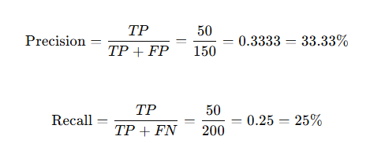
5. A binary classification model was evaluated on a test set of six samples.
The performance of the model is summarized in the following confusion matrix:
 | Predicted: 1 | Predicted: 0
Actual: 1 | 2 | 2
Actual: 0 | 1 | 1

Using this information, what is the value of the F1-score?
From the confusion matrix:
- True Positives (TP) = 2
- False Negatives (FN) = 2
- False Positives (FP) = 1
- True Negatives (TN) = 1
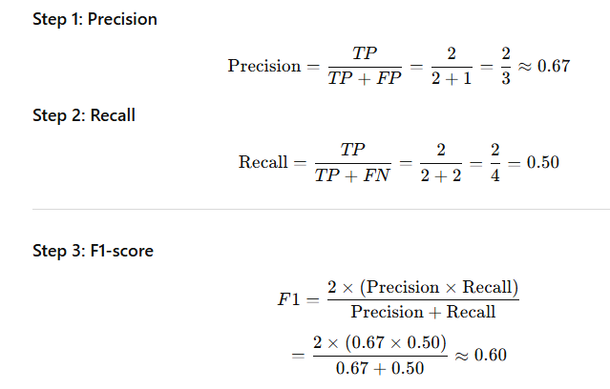
Problem: 6
Actual \ Predicted | Adelie | Chinstrap | Gentoo
Adelie | 48 | 4 | 3
Chinstrap | 5 | 42 | 3
Gentoo | 2 | 6 | 37

Total Samples

48+4+3+5+42+3+2+6+37=150

Correctly Classified Penguins
Diagonal elements:

48+42+37=127

Overall Accuracy

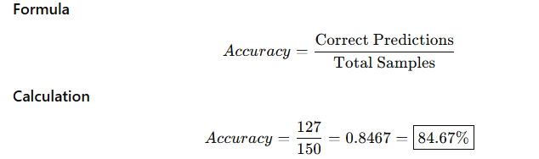

Precision, Recall & F1-Score

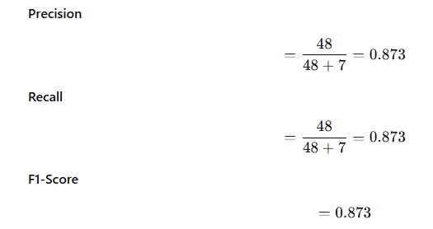

Chinstrap
- TP = 42
- FP = 4 + 6 = 10
- FN = 5 + 3 = 8

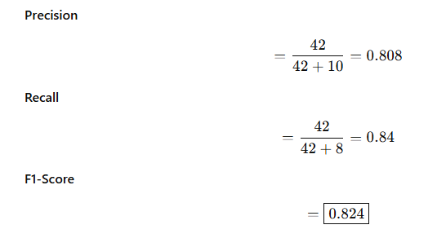

Gentoo
- TP = 37
- FP = 3 + 3 = 6
- FN = 2 + 6 = 8

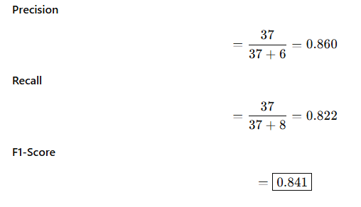
Species | Precision | Recall | F1-Score
Adelie | 0.873 | 0.873 | 0.873
Chinstrap | 0.808 | 0.840 | 0.824
Gentoo | 0.860 | 0.822 | 0.841

